OVLP Academic Year 2025-26
Duration: April 6 - 10, 2026 |  |  | Grade: Pre-Nursery |  | Subjects: All
Term III |  |  |  | Week: 6
 | English | Urdu |  | Math |  | HCD | IT
Links | class story  class story  The Dark Forest The Little Firefly  https://drive.google.com/file/d/1L9pUorlMogVSLUpbl2MxG3qFKdzqsfCA/view?usp=sharing  The Kind Farmer and the Clever Cow  https://drive.google.com/file/d/1PjpGDXqaMBzFycjlhqpkM_y4mYPm-Kwf/view?usp=sharing  Letter u  https://drive.google.com/file/d/16gT-5-YGsKgostrKDHbHrvBsTXi_tmGN/view?usp=share_link  Reading Letter u  https://drive.google.com/file/d/1Fz45cGVm3b9ojTox61sVOOsj-0q6ypEl/view?usp=sharing | Class story  Murghi or chiriya  https://drive.google.com/file/d/1l1Gdko6TYpm5cb6e8JHlenTX2PK9_s5h/view?usp=sharing  Bhalu ka bacha  https://drive.google.com/file/d/1ncUv2pL3RmwAOLrY5lHQ84rCgscjfDzj/view?usp=sharing  Ont or Saya  https://drive.google.com/file/d/1kickcOMQo0xpV-bJFEhDATb68gkuEENC/view?usp=sharing  Harf swaad.  https://drive.google.com/file/d/1z6CsAWzM2HwSD3paT7cr8vsBt3M1eisy/view?usp=share_link  Reading Harf swaad.  https://drive.google.com/file/d/1v9NfPWla7rE4R9aLmclhEHBgo4b9O4jC/view?usp=sharing |  | Number 20.  https://drive.google.com/file/d/1jhaLMgHOgsk3vEhRJAuOmuqeWMoswNHn/view?usp=sharing  Reading Number 20.  https://drive.google.com/file/d/1CGZo4t7TyvTQ4BWnTkdfkqynbfWzcUUl/view?usp=sharing |  | P.N TIIISRP6 | Week 6 OVLP Grade Pre-Nursery IT Term 3.mp4
Day 1  C.W | - Write the first letter of the pictures. (sun, tomato, umbrella, orange)  Note book pg. # 10  - Tick and color the picture starting with letter ‘u’ (pen, umbrella, orange,)  Note book pg. # 11  - Write a-u.  - Note book pg. # 12 | 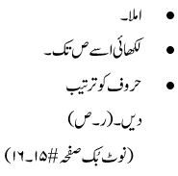 |  | - Backward counting (5 - 0) in the form of fill in the blanks.  - Tick and color the few objects.  Note book pg. # 9  - Writing (0 - 20)  - Circle all 20.  - Note book pg. # 11
Home work | _____________ |  |  |  |  | -

Term III |  |  | Week: 6
 | English | Urdu | Math | HCD | IT
Links | Letter v  https://drive.google.com/file/d/1Pdg3BcJ3e5xoAVFgV0AQmHX86gsBMby7/view?usp=share_link  Reading Letter v  https://drive.google.com/file/d/1p47IhKX4NzvYzYxAeeoEQKTUw48B0PE8/view?usp=sharing | harf zwaad.  https://drive.google.com/file/d/1aW6f7kSFetV7CnVJ7RaQSw-1jB1GZHbj/view?usp=share_link  Reading harf zwaad.  https://drive.google.com/file/d/17jAN-R8poOVfZNzs-dbN3Dvm6_P4hmyB/view?usp=sharing | Number 21.  https://drive.google.com/file/d/1cxecMQv3rqQDBk7YJHHqAHZnjih_4GVg/view?usp=share_link
Day 2  C.W | - Writing “v”.  - Draw a picture with letter “v” (vegetable, van or vase).  - Note book pg. # 13 | 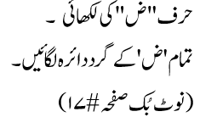 | Reading number 21
Home work | - Writing “v”.  - Draw a picture with letter “v” (vegetable, van or vase).  Note book pg. # 14
Day 3  C.W | Reading letter v. | 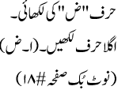 | - Write number 21.  - Tracing of star & first letter of the shape (Small “s”)  - Note book pg. # 12
Home work | _________________ | 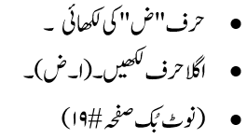
Day 4 | - Writing ‘v’.  - Match the letter with pictures. (snake, toy, umbrella, and violin)  Note book pg. # 15-16 | 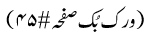 | - Write number 21.  - What comes next?  17_____ 19______ 11_____ 15______ 20_____.  - Join the dots to make star shape and write 1st letter of the shape.  - Note book pg. # 13
Home work |  |  | - Write number 21.  - What comes next?  17_____ 19______ 11_____ 15______ 20_____.  - Join the dots to make star shape and write 1st letter of the shape.  Note book pg. # 14
Day 5  C.W | - Fill in the blanks. (a –v).  - Circle the correct letter of pictures. (sun, torch, utensils, vase)  - Note book pg. # 17 | 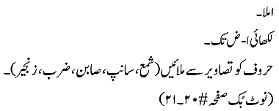 | - Dictation.  - Backward counting (5-0)  - Write the first letter of shapes. (heart, square and star)  Note book pg. # 15
Home work |  | Reinforcement sheet.  OGA will be taken on Monday.

